- Entity Relationship Diagram (ERD)

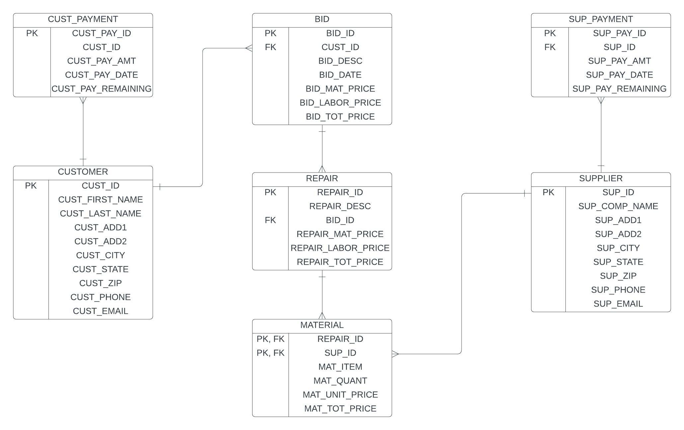

- Table Creation

CREATE TABLE CUST_PAYMENT (
CUST_PAY_ID INT NOT NULL UNIQUE,
CUST_ID INT NOT NULL,
CUST_PAY_AMT NUMERIC(8,2) NOT NULL,
CUST_PAY_DATE DATE NOT NULL,
CUST_PAY_REMAINING NUMERIC(8,2) NOT NULL,
PRIMARY KEY (CUST_PAY_ID))

CREATE TABLE SUP_PAYMENT (
SUP_PAY_ID INT NOT NULL UNIQUE,
SUP_ID INT NOT NULL,
SUP_PAY_AMT NUMERIC(8,2) NOT NULL,
SUP_PAY_DATE DATE NOT NULL,
SUP_PAY_REMAINING NUMERIC(8,2) NOT NULL,
PRIMARY KEY (SUP_PAY_ID))

CREATE TABLE CUSTOMER (
CUST_ID INT NOT NULL UNIQUE,
CUST_FIRST_NAME VARCHAR(30) NOT NULL,
CUST_LAST_NAME VARCHAR(30) NOT NULL,
CUST_ADD1 VARCHAR(30) NOT NULL,
CUST_ADD2 VARCHAR(30) ,
CUST_CITY VARCHAR(30) NOT NULL,
CUST_STATE VARCHAR(30) NOT NULL,
CUST_ZIP VARCHAR(10) NOT NULL,
CUST_PHONE VARCHAR(15) NOT NULL,
CUST_EMAIL VARCHAR(30) NOT NULL,
PRIMARY KEY (CUST_ID))

CREATE TABLE SUPPLIER (
SUP_ID INT NOT NULL UNIQUE,
SUP_COMPANY_NAME VARCHAR(30) NOT NULL,
SUP_ADD1 VARCHAR(30) NOT NULL,
SUP_ADD2 VARCHAR(30) ,
SUP_CITY VARCHAR(30) NOT NULL,
SUP_STATE VARCHAR(30) NOT NULL,
SUP_ZIP VARCHAR(10) NOT NULL,
SUP_PHONE VARCHAR(15) NOT NULL,
SUP_EMAIL VARCHAR(30) NOT NULL,
PRIMARY KEY (SUP_ID))

CREATE TABLE BID (
BID_ID INT NOT NULL UNIQUE,
CUST_ID INT NOT NULL,
BID_DESC VARCHAR(50) NOT NULL,
BID_DATE DATE NOT NULL,
BID_MAT_PRICE NUMERIC(8,2) NOT NULL,
BID_LABOR_PRICE NUMERIC(8,2) NOT NULL,
BID_TOT_PRICE NUMERIC(8,2) NOT NULL,
BID_LABOR_HOURS NUMERIC(8,2) NOT NULL,
PRIMARY KEY (BID_ID),
FOREIGN KEY (CUST_ID) REFERENCES CUSTOMER)

CREATE TABLE REPAIR (
REPAIR_ID INT NOT NULL UNIQUE,
REPAIR_DESC VARCHAR(50) NOT NULL,
BID_ID INT NOT NULL,
REPAIR_MAT_PRICE NUMERIC(8,2) NOT NULL,
REPAIR_LABOR_PRICE NUMERIC(8,2) NOT NULL,
REPAIR_TOT_PRICE NUMERIC(8,2) NOT NULL,
PRIMARY KEY (REPAIR_ID),
FOREIGN KEY (BID_ID) REFERENCES BID)

CREATE TABLE MATERIAL (
REPAIR_ID INT NOT NULL,
SUP_ID INT NOT NULL,
MAT_ITEM VARCHAR(50) NOT NULL,
MAT_QUANT INT NOT NULL,
MAT_UNIT_PRICE NUMERIC(8,2) NOT NULL,
MAT_TOT_PRICE NUMERIC(8,2) NOT NULL,
PRIMARY KEY (REPAIR_ID, SUP_ID),
FOREIGN KEY (REPAIR_ID) REFERENCES REPAIR,
FOREIGN KEY (SUP_ID) REFERENCES SUPPLIER)

- Sample Data Population

INSERT INTO CUST_PAYMENT VALUES (1, 1, 1100, '1/31/24', 1000)
INSERT INTO CUST_PAYMENT VALUES (2, 1, 1100, '2/29/24', 0)
INSERT INTO CUST_PAYMENT VALUES (3, 2, 500, '3/15/24', 500)
INSERT INTO CUST_PAYMENT VALUES (4, 3, 250, '3/20/24', 250)
INSERT INTO CUST_PAYMENT VALUES (5, 4, 750, '5/20/24', 650)

INSERT INTO SUP_PAYMENT VALUES (1, 1, 300, '11/15/23', 300)
INSERT INTO SUP_PAYMENT VALUES (2, 1, 300, '12/15/23', 0)
INSERT INTO SUP_PAYMENT VALUES (3, 1, 250, '1/31/24', 250)
INSERT INTO SUP_PAYMENT VALUES (4, 2, 500, '2/29/24', 500)
INSERT INTO SUP_PAYMENT VALUES (5, 1, 250, '3/15/24', 0)

INSERT INTO CUSTOMER VALUES (1, 'Jack', 'Hill', '123 Waipa Ln', 'Apt 202', 'Honolulu', 'HI', '96817', '808-232-3344', 'jhill@gmail.com')
INSERT INTO CUSTOMER VALUES (2, 'Jill', 'Thomas', '456 Nanakai St', 'Suite 101', 'Pearl City', 'HI', '97602', '808-456-3465', 'jill65@yahoo.com')
INSERT INTO CUSTOMER VALUES (3, 'Anthony', 'Hatcher', '789 S King St', '', 'Ewa Beach', 'HI', '96826', '808-845-9873', 'tonyhatch@gmail.com')
INSERT INTO CUSTOMER VALUES (4, 'Harley', 'Quin', '234 Beratania St', '', 'Kaimuki', 'HI', '96822', '808-354-3294', 'hq3364@yahoo.com')
INSERT INTO CUSTOMER VALUES (5, 'Anne', 'Cruz', '345 Smith Dr', '', 'Honolulu', 'HI', '96817', '808-772-3356', 'annie_cz24@gmail.com')

INSERT INTO SUPPLIER VALUES (1, 'Repair Supplies', '3422 Fort Weaver', '', 'Honolulu', 'HI', '96817', '808-643-2455', 'supplies@repairsupplies.com')
INSERT INTO SUPPLIER VALUES (2, 'Kaimuki Hardware', '5423 Main St', '', 'Honolulu', 'HI', '96826', '808-464-3897', 'info@kaimukihardware.com')
INSERT INTO SUPPLIER VALUES (3, 'City Suppliers', '4293 Waialae', 'Suite 100', 'Kaimuki', 'HI', '96822', '808-683-3862', 'jasonl@citysuppliers.com')
INSERT INTO SUPPLIER VALUES (4, 'Lowers', '5469 Kapiolani Blvd', '', 'Pearl City', 'HI', '97602', '808-839-3863', 'info@lowers.com')
INSERT INTO SUPPLIER VALUES (5, 'HNL Goods', '4326 2nd St', '', 'Honolulu', 'HI', '96827', '808-487-9872', 'accounts@hnlgoods.com')

INSERT INTO BID VALUES (1, 1, 'Includes 3 repairs', '10/10/23', 1600, 600, 2200, 44)
INSERT INTO BID VALUES (2, 2, 'includes 2 repairs', '11/14/23', 350, 150, 500, 50)
INSERT INTO BID VALUES (3, 3, 'Replace door to garage', '1/12/24', 400, 140, 540, 55)
INSERT INTO BID VALUES (4, 4, 'Broken handrail for stairs ', '1/12/25', 500, 200, 700, 42)
INSERT INTO BID VALUES (5, 5, 'Basement repairs', '1/12/25', 200, 100, 300, 60)

INSERT INTO REPAIR VALUES (1, 'Cabinet drawer', 1, 300, 100, 400)
INSERT INTO REPAIR VALUES (2, 'Primary closet racks', 1, 300, 100, 400)
INSERT INTO REPAIR VALUES (3, 'Primary bathroom cabinetry', 1, 1000, 400, 1400)
INSERT INTO REPAIR VALUES (4, 'Window screen holes', 2, 350, 150, 500)
INSERT INTO REPAIR VALUES (5, 'New door needed', 3, 200, 100, 300)

INSERT INTO MATERIAL VALUES (1, 1, 'Cabinet hinges', 4, 75, 300)
INSERT INTO MATERIAL VALUES (1, 2, 'Closet rails - 8ft, 4, 75, 300)
INSERT INTO MATERIAL VALUES (1, 3, '4ftx8ft lumber sheet', 4, 250, 1000)
INSERT INTO MATERIAL VALUES (2, 1, 'Window frame set', 3, 50, 150)
INSERT INTO MATERIAL VALUES (2, 2, 'Screen sheets', 3, 66.67, 200)

- Database Query Examples

a. List the names of the customers who provided bids last month.

SELECT (CUST_FIRST_NAME + ' ' + CUST_LAST_NAME) AS 'Customer Name'
FROM CUSTOMER JOIN BID
ON CUSTOMER.CUST_ID = BID.CUST_ID
WHERE MONTH(BID_DATE) = MONTH(DATEADD(month,-1 , SYSDATETIME()))
AND YEAR(BID_DATE) = YEAR(DATEADD(month,-1 ,SYSDATETIME()))

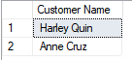

b. List all the customers that have an outstanding balance [amount due to you (Bob)] that is greater than $500.

SELECT (CUST_FIRST_NAME + ' ' + CUST_LAST_NAME) AS 'Customer', CUST_PAY_REMAINING as 'Outstanding Balance'
FROM CUSTOMER JOIN CUST_PAYMENT
ON CUSTOMER.CUST_ID = CUST_PAYMENT.CUST_ID
WHERE CUST_PAY_REMAINING > 500

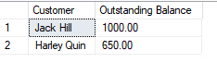

c. List all the suppliers where you (Bob) have an outstanding balance that is greater than $300.

SELECT SUP_COMPANY_NAME AS 'Supplier', SUP_PAY_REMAINING AS 'Outstanding Balance'
FROM SUPPLIER JOIN SUP_PAYMENT
ON SUPPLIER.SUP_ID = SUP_PAYMENT.SUP_PAY_ID
WHERE SUP_PAY_REMAINING > 300

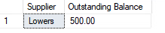

d. List all the material that was used for bids where the estimated hours for the bid was greater than 40 hours.

SELECT MAT_ITEM
FROM BID JOIN REPAIR
ON BID.BID_ID = REPAIR.BID_ID
JOIN MATERIAL
ON REPAIR.REPAIR_ID = MATERIAL.REPAIR_ID
WHERE BID_LABOR_HOURS > 40

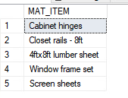

e. List all the material purchased from a specific supplier.

SELECT SUP_COMPANY_NAME, MAT_ITEM
FROM SUPPLIER JOIN MATERIAL
ON SUPPLIER.SUP_ID = MATERIAL.SUP_ID
WHERE SUP_COMPANY_NAME = 'Kaimuki Hardware'

